Course: PRF192 - Programming Fundamentals

Developer & Project Portfolio Management system

Group No: 7
Group Members | Trịnh Hưng Tuấn – SE201071  Nguyễn Hoàng Duy – SE201125  Huỳnh Ngọc Thông – SE201031  Nguyễn Thái Bình – SE200727
Lecturer | Lê Thị Hồng Nga
Class | SE2005

Ho Chi Minh, ngày 7 tháng 2 năm 2026

Table of Contents

Table of Contents.
1. Introduction
1.1. Project Description
1.2. Project Team
2. Requirement Analysis & Decomposition
2.1. Data.
2.2. Functions.
3. Algorithm Design & Flowcharts.
4. Implementation of Basic Functions.
5. Structure Design
6. File I/O & Testing.
7. Experimental Results.
8. Appendix.

1. Introduction

1.1. Project Description
The project develops a : Developer & Project Portfolio Management system using the C programming language.
The program allows managing developer profiles, searching, sorting, and saving/reading data from files, while applying struct and struct arrays.
1.2. Project Team
Order | Student ID | Full Name | Completion Level | Tasks Performed
1 | SE201031 | Huỳnh Ngọc Thông | 10/10 | Read the needed requirement
2 | SE200727 | Nguyễn Thái Bình | 10/10 | Research and implement
3 | SE201071 | Trịnh Hưng Tuấn | 10/10 | Planning
4 | SE201125 | Nguyễn Hoàng Duy | 10/10 | Analyze project, do function of modules

2. Requirement Analysis & Decomposition

2.1. Data
Order | Name | Description
1 | Developer ID | Format: DEVxxx, unique
2 | Full Name | minimum 2 words
3 | Birth Year | Year of birth
4 | Programming Languages | List of programming language
5 | Monthly Salary | minimum $1000
6 | Project ID | Unique project identifier (Format: PRJxxx)
7 | Project Name | Name of the project
8 | Developer ID | ID of the developer assigned to the project (Format: DEVxxx)
9 | Duration | months (The time developer is working)
10 | Start Date | Project start date
11 | Project status | Status of project (doing or completed)
12 | End date | Project end date

2.2. Functions
Developer & Project Portfolio Management system have 5 mains Function
- A. Developer Management
- B. Project Assignment
- C. Data Analysis & UI
- D. User Interface:
- E. File I/O:

Order | Function | Description
1 | Add new developers | Add a new Developer.
2 | Check name | - Minimum 2 words  - Verify the validity of the full name.
3 | Validate Developer ID | Check the format is correct: DEVxxx, unique.
4 | Update developer | Update the new Developer (Name, ID of the new developer).
5 | Delete developer | Fire a Developer (requires full name and developer ID).
6 | Find developer by ID | Find Developer by ID.
7 | Validate salary | minimum $1000.
8 | Update salary | Salary update (current salary, highest salary).
9 | Add project | Add new project.
10 | Assign project | Assign projects to individual developers.
11 | Experience total | Calculate the number of years of experience a Developer has.
12 | Display group developer | Display the number of projects each developer is involved in.
13 | Search by Name | Find developers by name
14 | Search by ID | Find developers by ID
15 | Sort developer by salary | Sort programmers by salary.
16 | Sort developer by Name | Sort programmers by name
17 | Sort developer by Birth Year | Sort programmers by date of birth.
18 | Load projects | Read projects
19 | Save projects | Save the project after execution.
20 | File Validation | Check if the file exists.
21 | Show main menu | show menu
22 | Submenu Developer | Developer management menu
23 | Submenu Project | Show project menu

3. Algorithm Design & Flowcharts
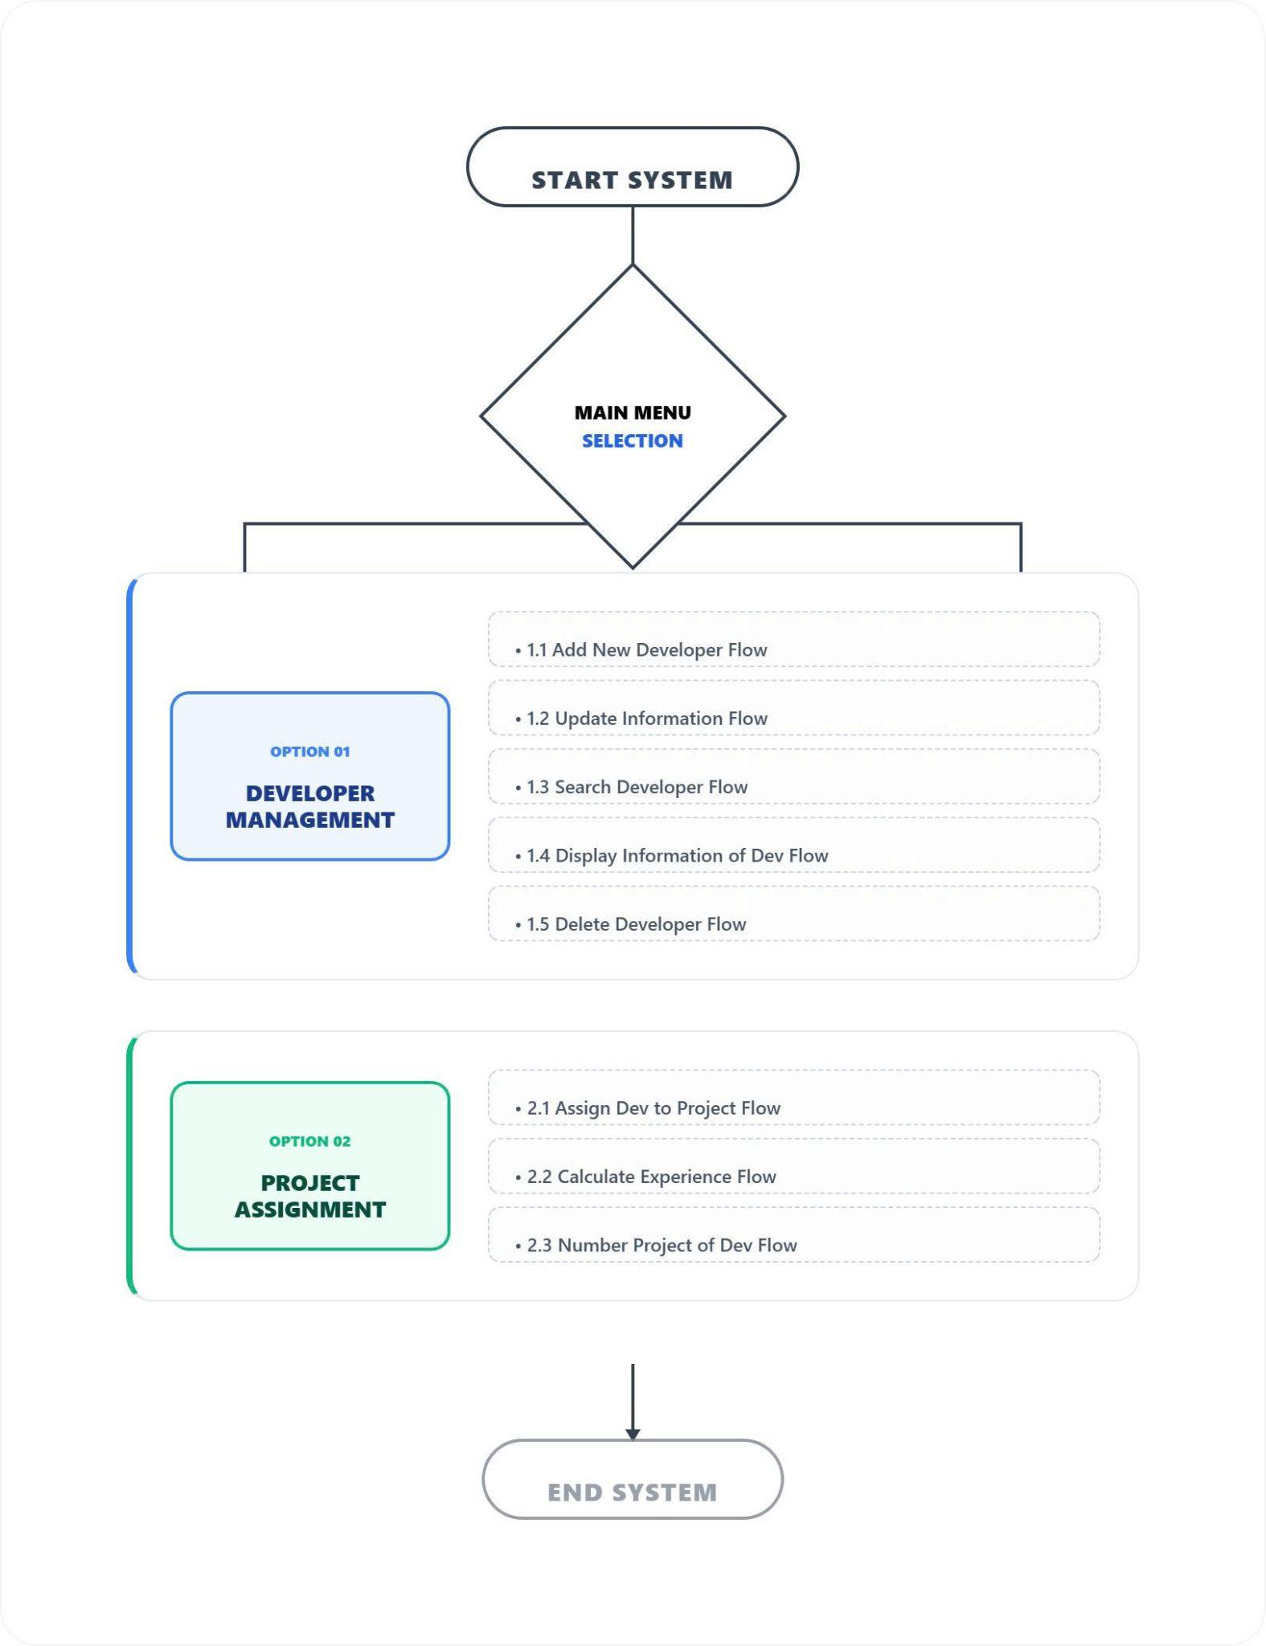

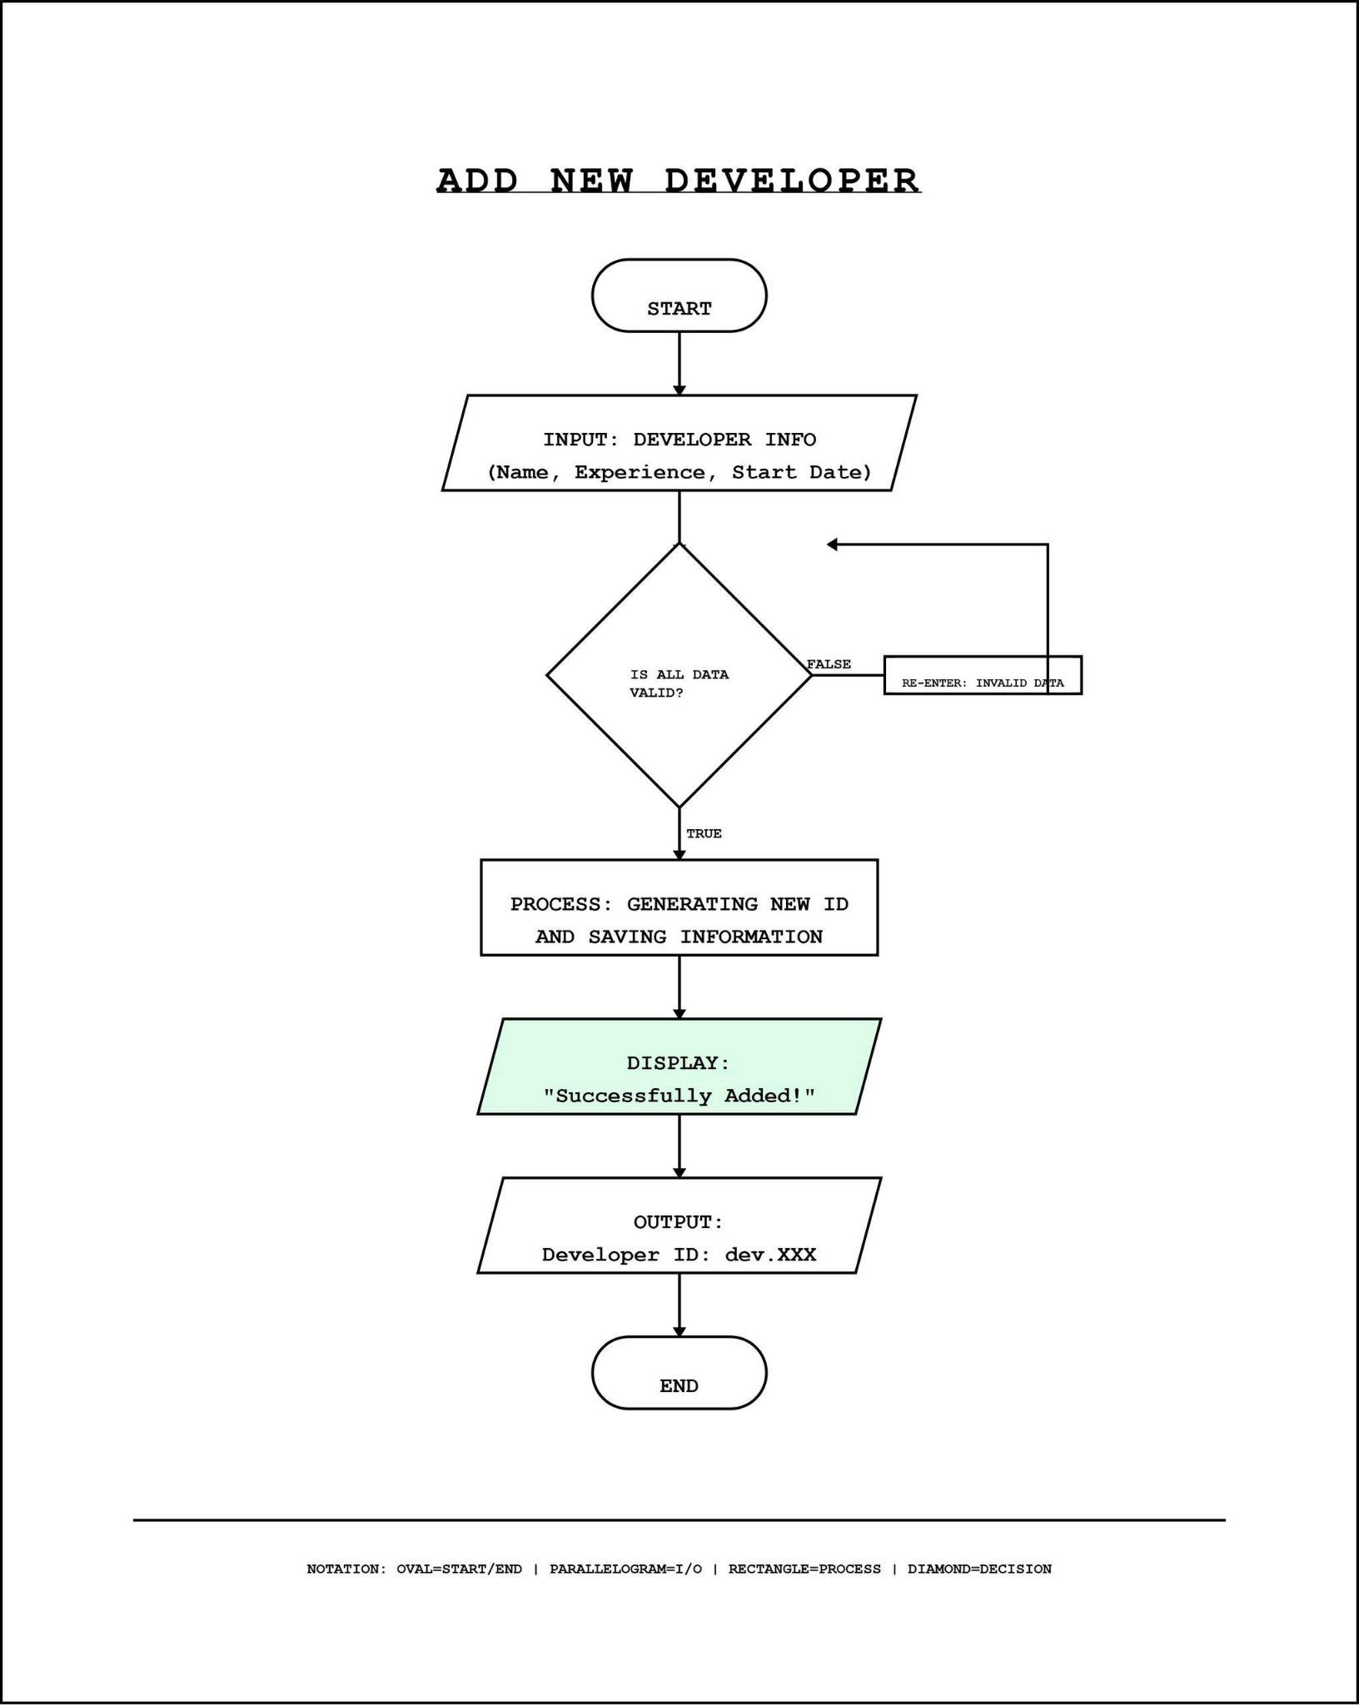

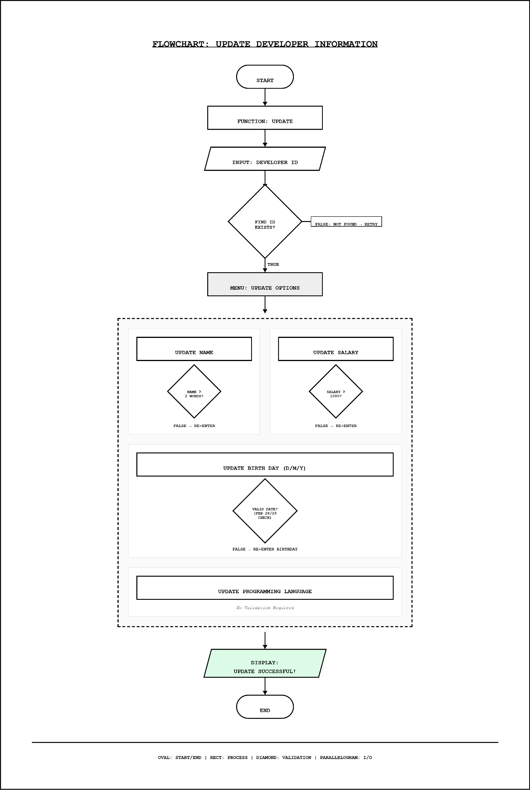
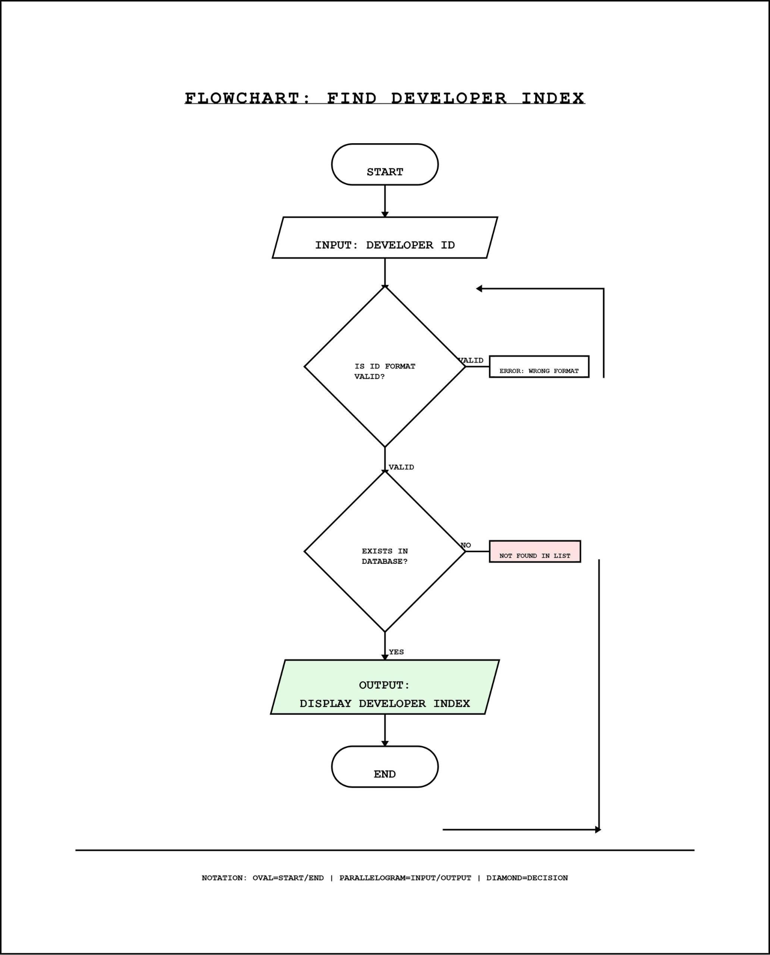
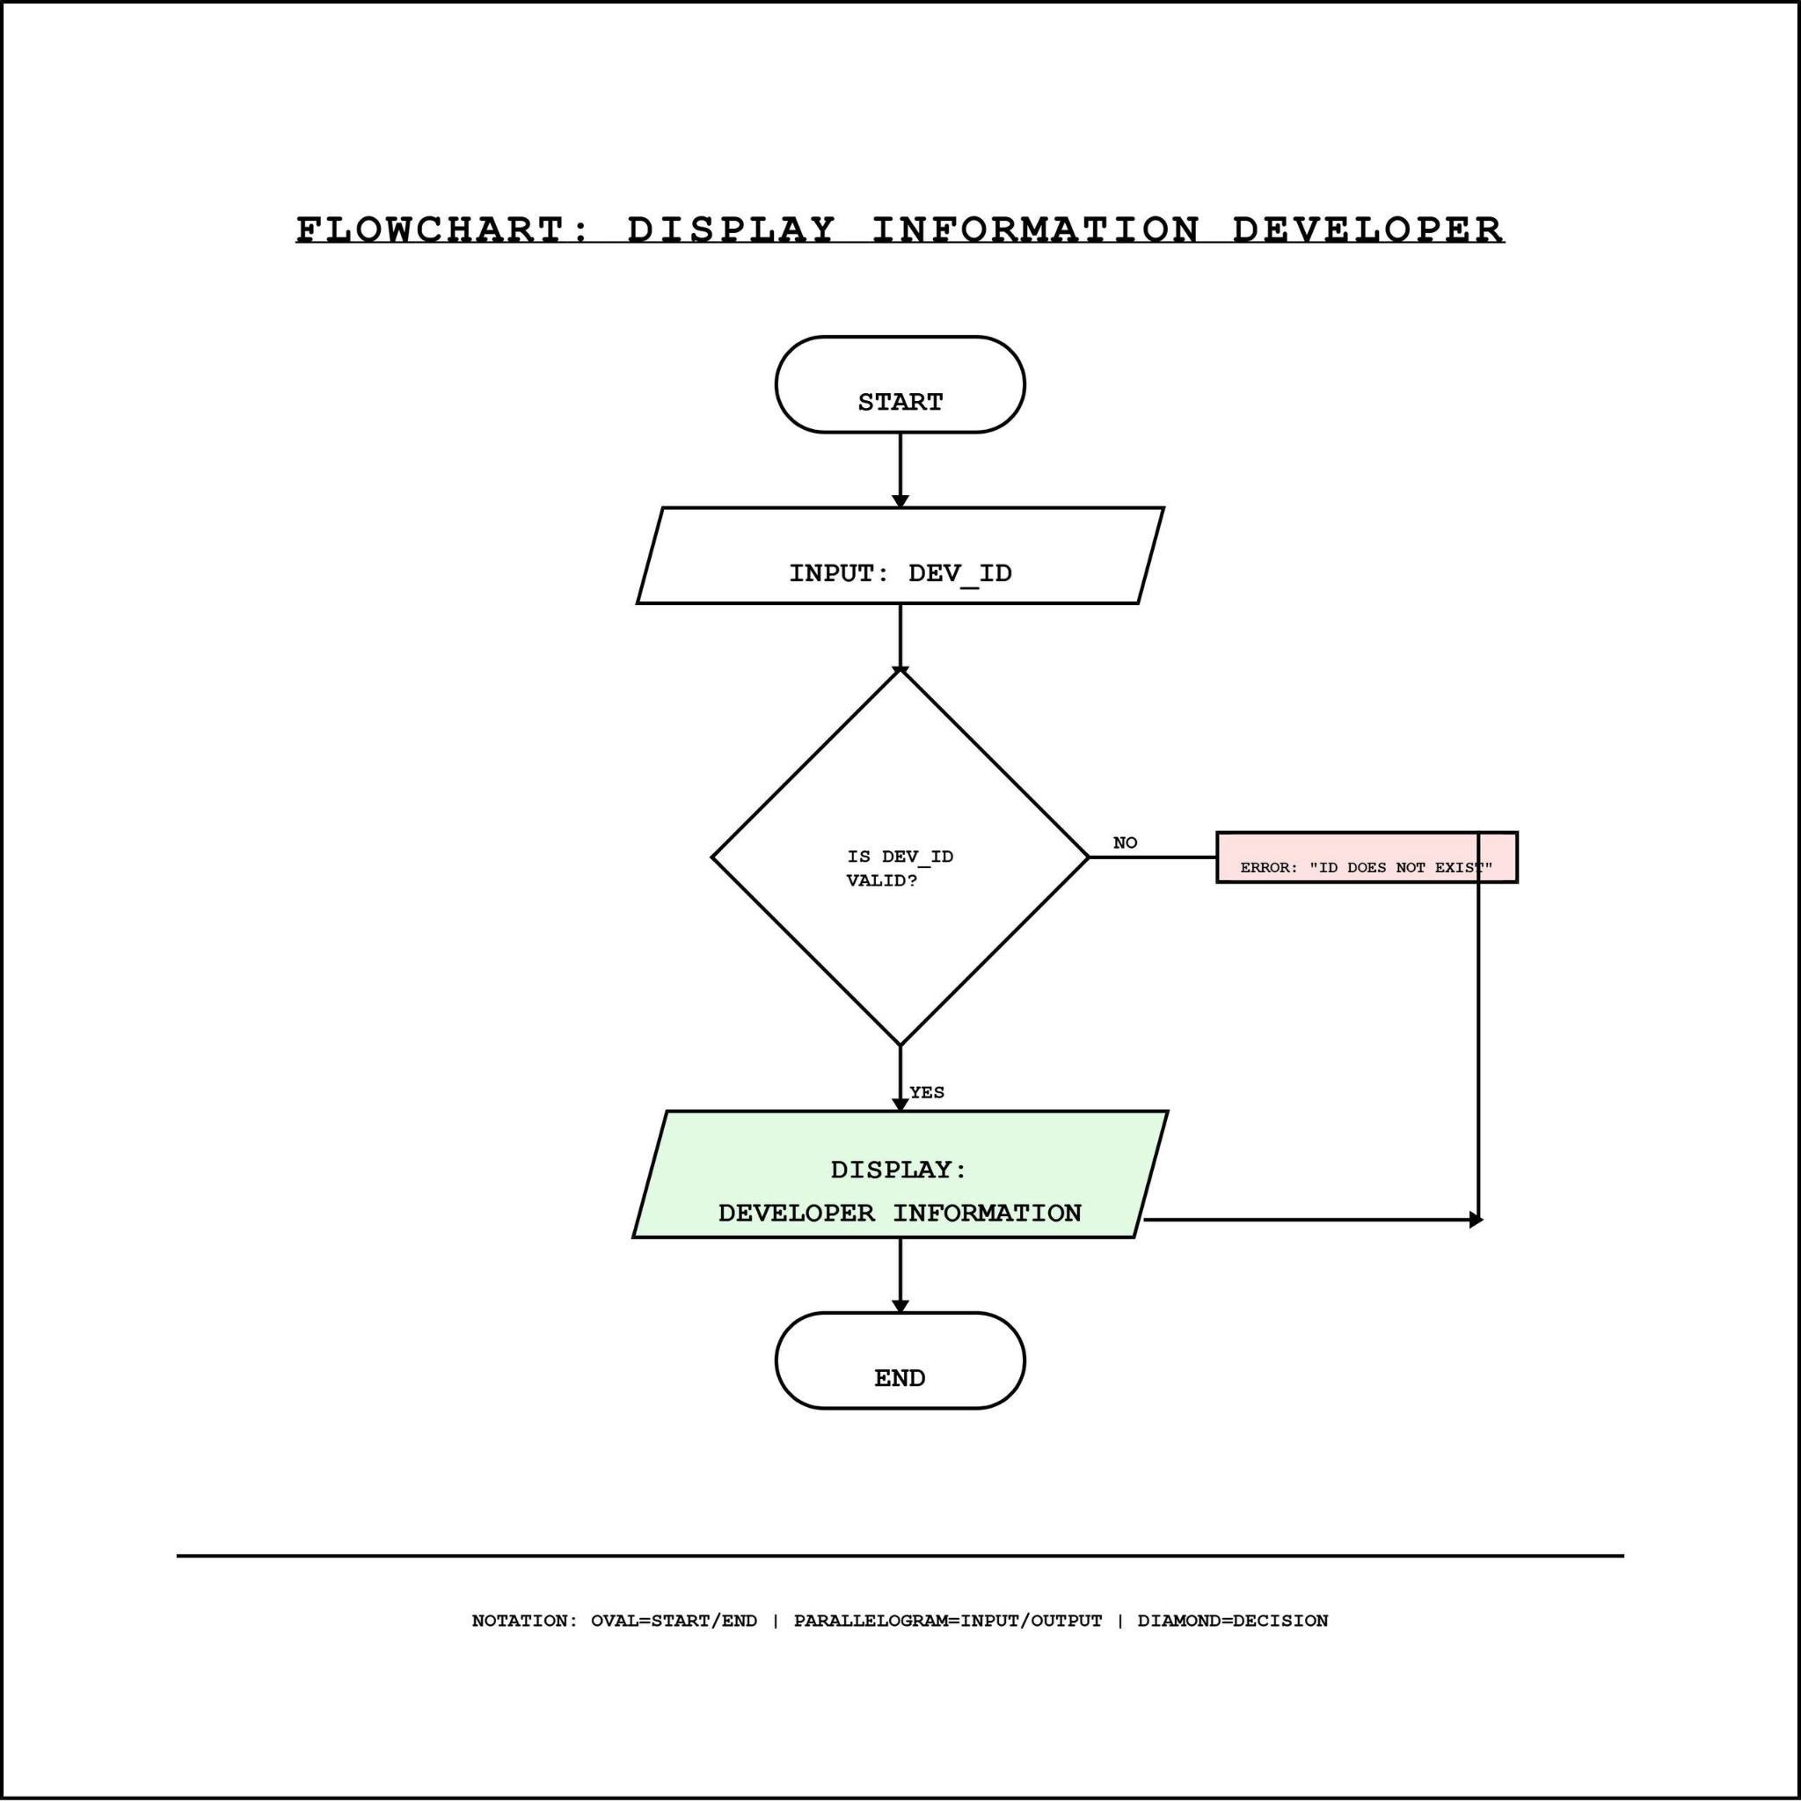

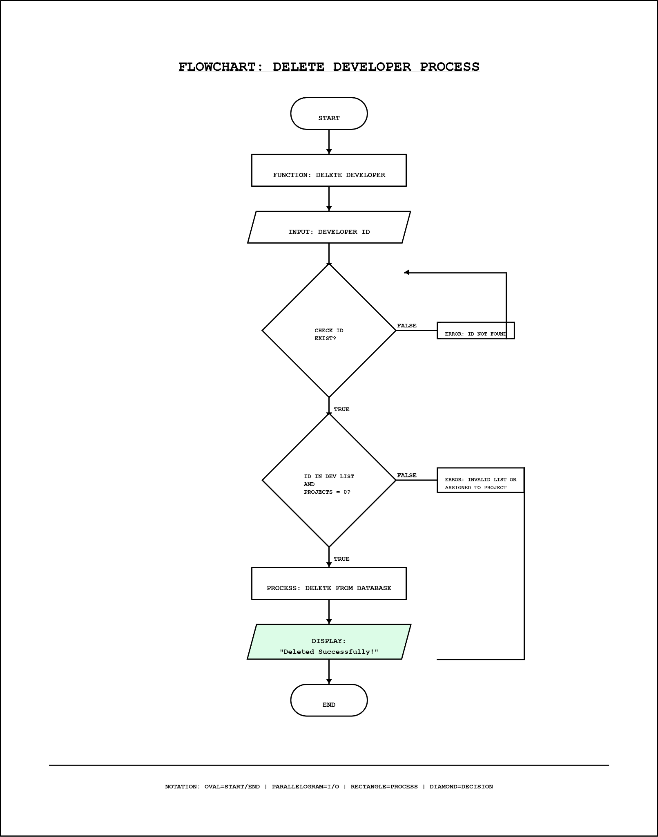
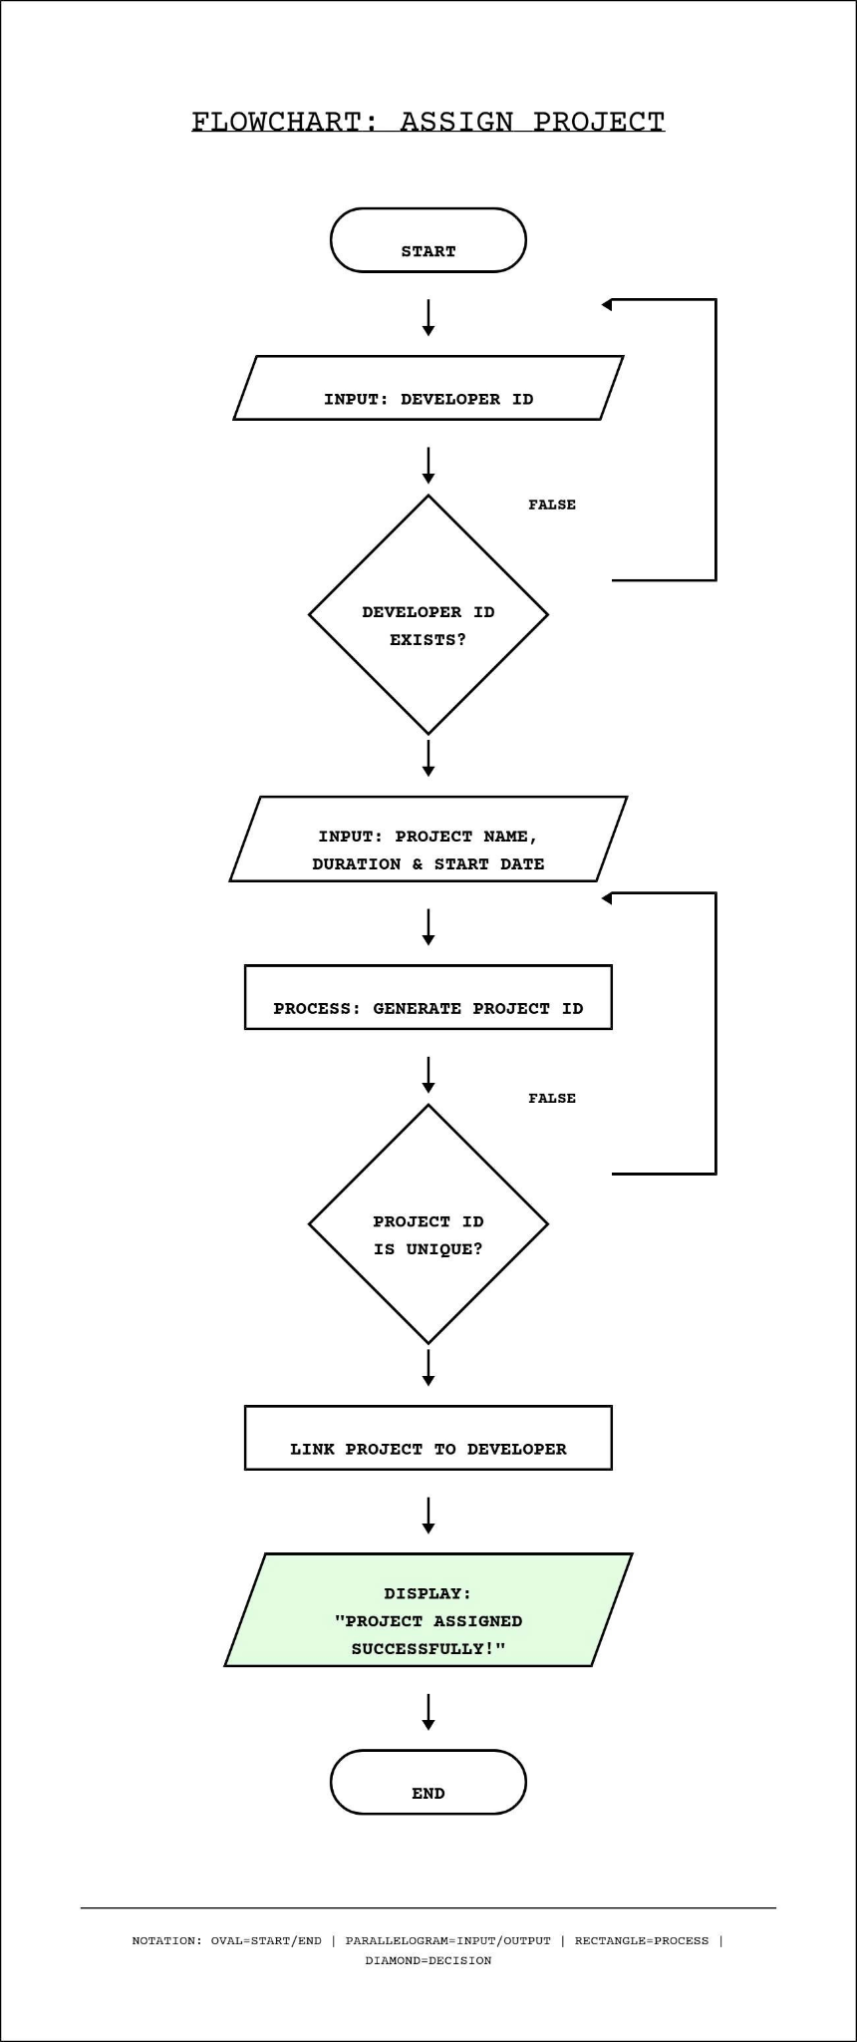
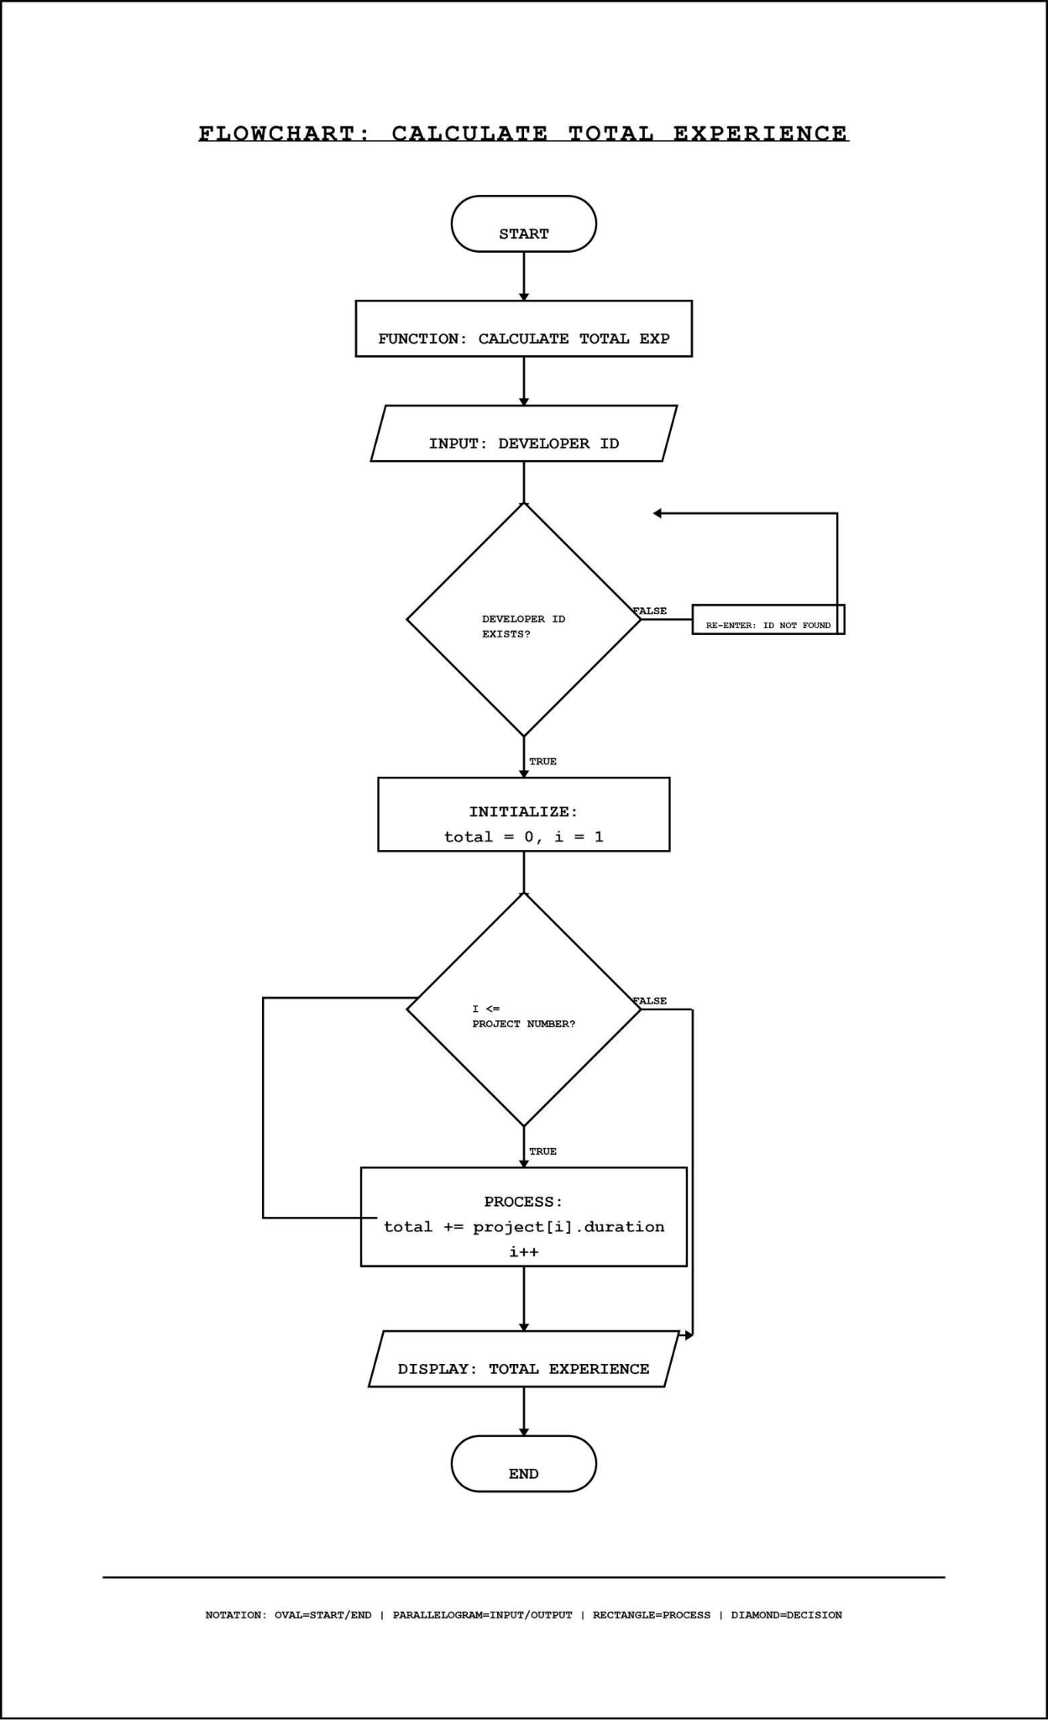

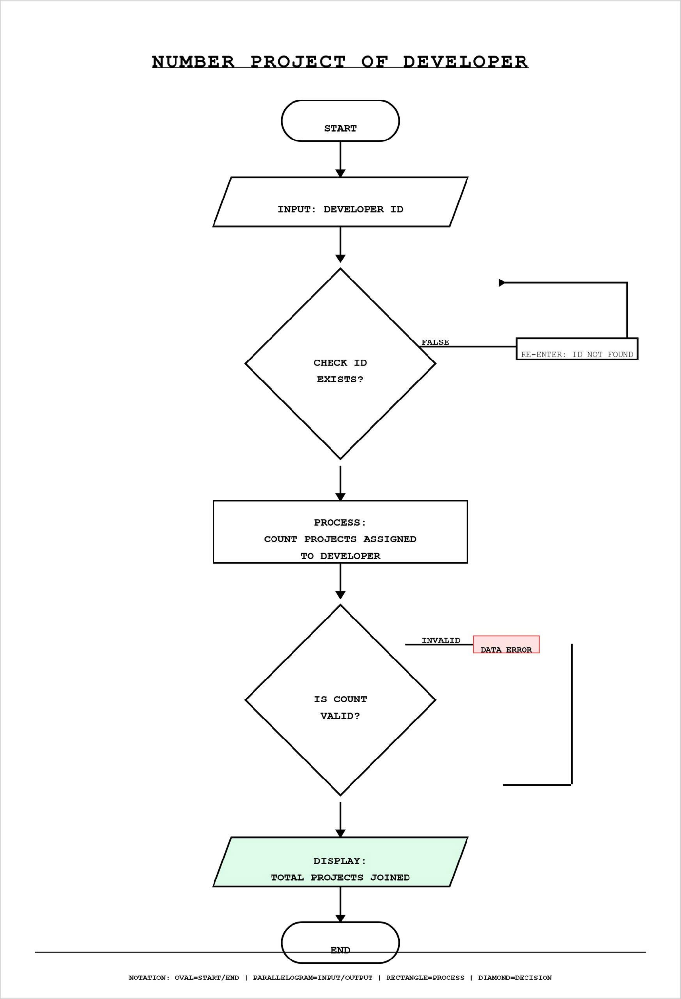

4. Implementation of Basic Functions

- update Developer

void updateDeveloper(Developer developers, int devCount)
INPUT ID cần update
Khai báo int index = FindID(developers, devCount, id)
IF index == -1
→ RETURN
- *Developer d = &developers[index] → Khai báo con trỏ d
INPUT choice (field cần update)
SWITCH (choice)
CASE 1
→ INPUT new name
→ Check NameValidation(Developer developers, int devCount, char name[] )
⇒ TRUE ⇒ d → name = new name;
⇒ (The developer information is added to the developer list using dynamic memory. )
Update successfully
⇒ FALSE → Yêu cầu nhập lại
CASE 2
→ INPUT new birth year
⇒ d→ birth = new birth
⇒ (The developer information is added to the developer list using dynamic memory. )
Update Successfully
CASE 3
→ INPUT new language
⇒ d→language = new language
⇒ (The developer information is added to the developer list using dynamic memory. )
**Update successfully**

CASE 4
→ INPUT new salary
⇒ Check SalaryValidation(Developer developers, int devCount, double new salary)
⇒ TRUE ⇒ d→ salary = new salary
(The developer information is added to the developer list using dynamic memory. )
Update successfully
⇒ FALSE → Yêu cầu nhập lại
DEFAULT
→ nothing
RETURN

- Find Developer by ID

int FindID (Developer developers, int devCount, char id[]){
For ( khởi tạo biến i = 0 → devCount ){
IF con trỏ developer[i] → id== id RETURN vị trí của id trong developers → i
}
Kết thúc vòng lặp for nhưng không tìm được → RETURN -1;
}

DeleteDeveloper(Developer developers, int devCount ){
INPUT ID cần Delete
Khai báo int index = FindID(developers, devCount, id);
IF (index ≠ -1 ){
→ FALSE → In ra màn hình “This id is not found” → RETURN
→ TRUE → Tiếp tục
}
FOR (i = index → devCount - 2){
developers[i] = developers[i + 1];
}
devCount - -
realloc mảng developers với kích thước mới
RETURN
}

- Display Developer
void DisplayDeveloper(_)
Step 1: Thuật toán bắt đầu
Step 2: Check developer list
⇒ Nếu FALSE → In ra màn hình “No developer to display” → RETURN
⇒ Nếu TRUE → Tiếp tục
Step 3: Duyệt từng học sinh trong Developer list
⇒ In ra từng thông tin cơ bản của developer list
⇒ Bao gồm:
- DevID,
- DevName
- , DevBirth,
- DevLanguage,
- DevSalary
Step 4: Kết thúc thuật toán

- Display Project
void DisplayProject(_)
Step 1: Thuật toán bắt đầu
Step 2: Check project list
⇒ Nếu FALSE → In ra màn hình “No project to display” → RETURN
⇒ Nếu TRUE → Tiếp tục
Step 3: Duyệt từng học sinh trong project list
⇒ In ra từng thông tin cơ bản của project list
⇒ Bao gồm:
- ProjectID,
- ProjectName
- StartDate
- Duration
Step 4: Kết thúc thuật toán

- Delete Developer
DeleteDeveloper(Developer developers, int devCount ){
INPUT ID cần Delete
Khai báo int index = FindID(developers, devCount, id);
IF (index ≠ -1 ){
→ FALSE → In ra màn hình “This id is not found” → RETURN
→ TRUE → Tiếp tục
}
FOR (i = index → devCount - 2){
developers[i] = developers[i + 1];
}
devCount - -
realloc mảng developers với kích thước mới
RETURN
}

- Add new developer
Step 1: Start
Step 2: Enter set information of Dev :
- Name of Dev
- Start day to work
- Birth day
Step 3: Check set information:
If the set of developer information is invalid:
→ Display message “invalid data. Please enter again”.

→ Return to Step 2

If the set of developer information is valid:
→ Continue to the next step.

Step 4: Generate a new developer ID
- Enter developer ID and ensure uniqueness
Step 5:
- Increase the size of the dynamic array to add one more developer.
- Store the new developer’s information (ID, name, start day, birth day) at the end of the array.
- Update the total number of developers.
The developer list is stored in a dynamically allocated array.
Step 6:
- The system displays the message “ Successfully Added!”

- Assign Project

Step 1: Start

Step 2: Enter developer ID
The user enters a developer ID.

Step 3: Find developer index
- Call the find function to search for the developer ID in the dynamic array:
index ←FindID(developer, devcount, id)
- The function returns:
  - the index of the developer if found,
  - or 1 if the developer ID does not exist.
- If index==-1:
  - Display the message “Developer ID not found. Please enter again.”
  - Return to Step 2.
- If index≠-1:
  - The developer ID is valid.
  - Continue to the next step.

Step 4: Enter project information
The user enters the project information, including:
- Project name
- Project duration
- Project start date

Step 5: Generate project ID
The system generates a project ID for the new project.

Step 6: Check project ID uniqueness
- Check whether the project ID already exists.
- If the project ID is not unique:
  - Generate the project ID again.
  - Repeat Step 5.
- If the project ID is unique:
  - Continue to the next step.

Step 7: Link project to developer
- Use the index to access the correct developer in the dynamic array.
- Add the new project to that developer.
- Increase the developer’s project coun

Step 8: Display result
The system displays the message: “Project assigned successfully!”

Step 9: End
The algorithm ends

5. Structures Design

6. File I/O & Testing

7. Experimental Results

8. Appendix

